**Software Engineering Department**

|  |  |  |  |
| --- | --- | --- | --- |
| **Course** | Database Systems | | |
| **Assessment Method** | Group Project | | |
| **Date of Assessment** | 10th December 2020 | **Duration / Deadline(s)** | 2 Weeks |
| **Maximum Mark** | 100 | **Percentage of Final Grade** | 20% |

|  |
| --- |
| **Instructions to Students**   1. This assessment has 10 pages including the cover page. 2. Students are allowed to use a MS Visio/Draw.io and SQL Server to design and implement the database 3. Each student is required to submit the project deliverables individually onto LMS |

|  |
| --- |
| **Academic Honesty Statement**  **• Students are required to refrain from all forms of academic dishonesty as defined**  **الأكاديمية.** |

|  |  |
| --- | --- |
| **Student Roll Number** | **Student Name** |
| BSEM-F19-095 | Bareerah Batool |
| BSEM-F19-190 | Muhammad Anas |
| BSEM-F19-062 | Ahmed Naeem |
| BSEM-F19-060 | Rasikh Ali |

|  |  |  |  |  |  |  |  |
| --- | --- | --- | --- | --- | --- | --- | --- |
| **Question (Section) No.** | **1** | **2** | **3** | **4** | **5** | **Total** | **%** |
| **Marks Allocated** | 8 | 8 | 32 | 32 | 20 | **100** | **25** |

Database Project

**Course:** Database Systems

Project on Capgemini Company

**Prepared for: Ma’am Tayyaba Farhat**

**Date: 12/10/2020**

**Prepared by:**

Bareerah Batool

Ahmed Naeem

Muhammad Anas

Rasikh Ali

**Section:** **BSSE-3B**

“This assignment is our own work. The sources of all quotations, both direct and indirect, have been fully cited; All material used in the preparation of this assignment has been acknowledged. This assignment has not been submitted for assessment in any other paper.”

Signed by:

|  |  |  |
| --- | --- | --- |
|  |  |  |

**Table of Contents**

➢ Capgemini Company Case Study 4

➢ The Entity Relationship Diagram 6

➢ Relational Model 7

➢ SQL (DDL) 8

➢ SQL (DML) 10

➢ SQL Query 16

## Capgemini Company Case Study

The necessary Entities are:

1. **Employee**

Employees will be working on None / one or more projects

1. **Contract**

Client will have a contract with Company about the Project client wants and will be assigned a Contract ID

1. **Client**

Client can make multiple contracts with company for Projects

1. **Project**

Project can have multiple employees or no employees working on it,

Project can use no or many resources at a time,

Project is Developed under Project Manager and is monitored by IT Department

1. **Resources**

Resources can be of hardware/software type and zero or more resources can be used in projects.

1. **Project Manager**

Project Manager is assigned to only one project at a time. 1 Project can have only one Project Manager

1. **IT Department**

IT Department Monitors all the projects and manages the budget. There is only one IT Department.

To describe about the attributes for each of the entity here is a table that describes about each of the attribute against each entity:

|  |  |
| --- | --- |
| **ENTITIES** | **ATTRIBUTES** |
| 1. **Employee** | EmployeeID, Name, Address, Birth_Date, Salary, Phone_No |
| 1. **Contract** | ContractID, ProjectID, ClientID, Contract_Date |
| 1. **Client** | ClientID, Name, Gender, Address, Phone_No |
| 1. **Project** | ProjectID, Project_Name, Starting_Date |
| 1. **Resources** | ResourceID, Resource_Type, Price, Brand |
| 1. **Project Manager** | Manager_ID, Name, Gender, Address, Phone_No |
| 1. **IT Department** | IT_Dept_ID, Director, Director_Contact_No, Department_Mail, Budget |

## The Entity Relationship Diagram

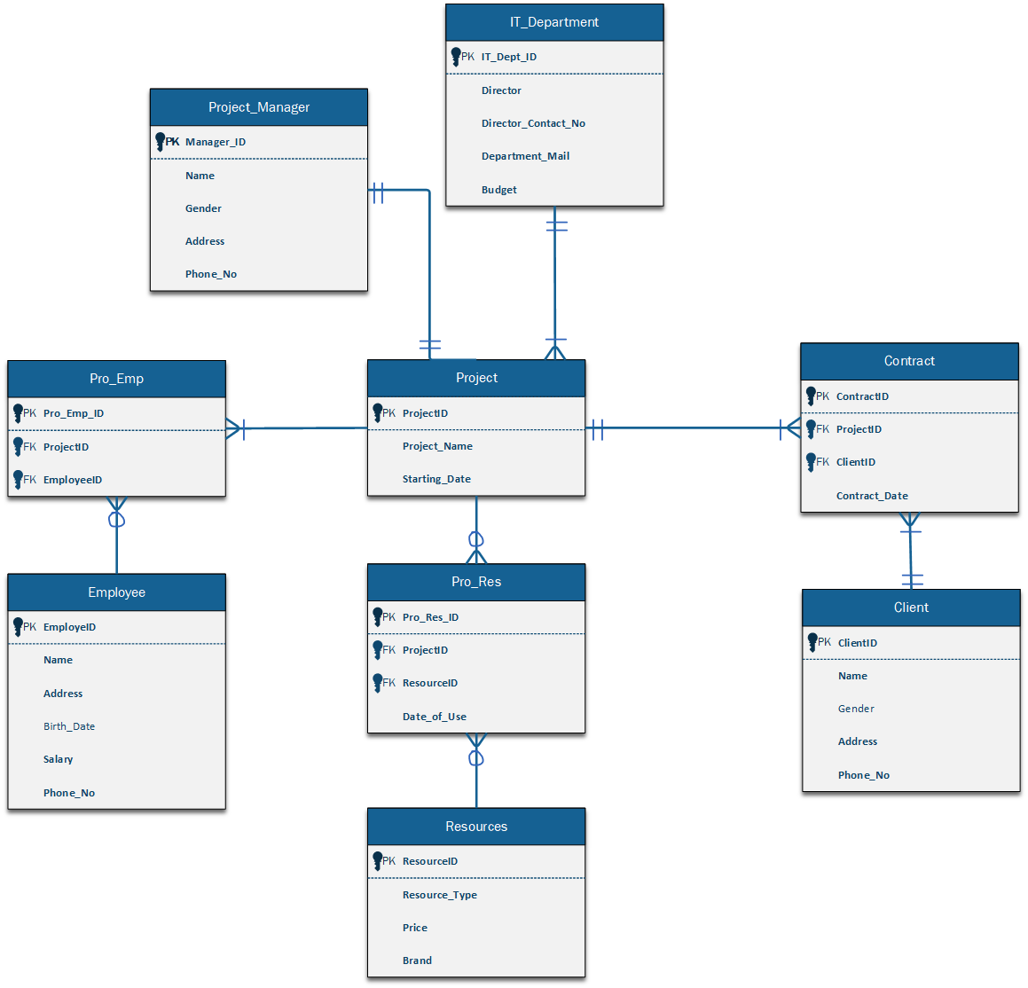

## Relational Model

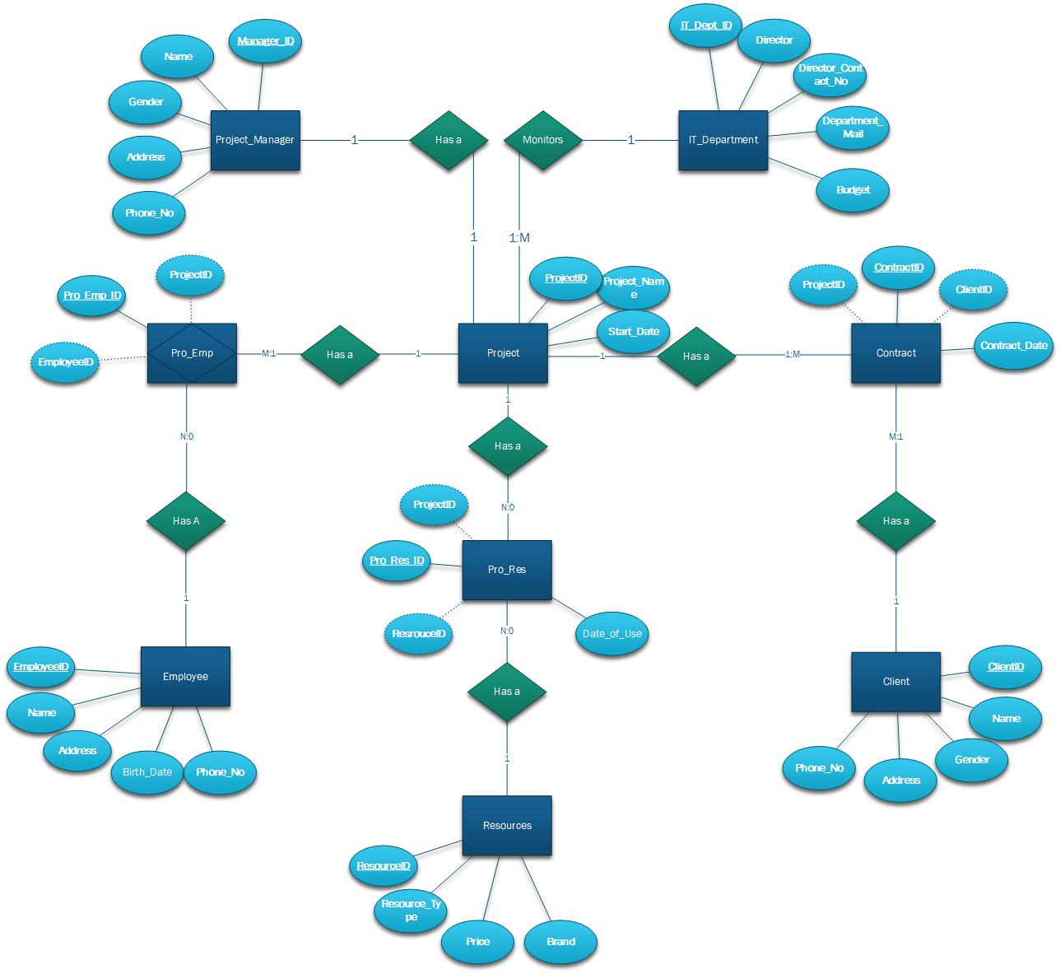

## SQL (DDL)

**Employee**

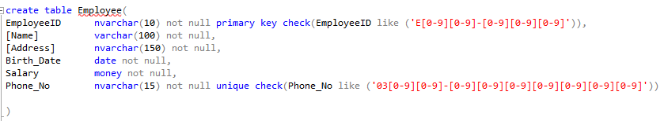

**Project**

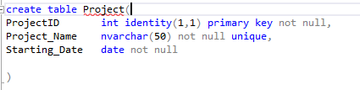

**Pro_Emp**

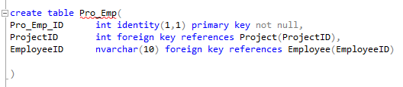

**Project_Manager**

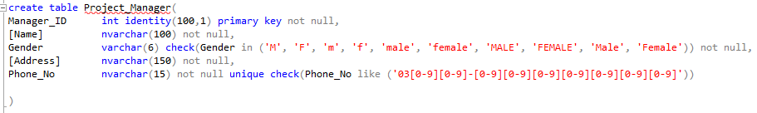

**Pro_Man**

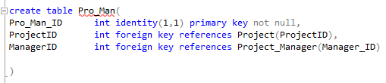

**Resources**

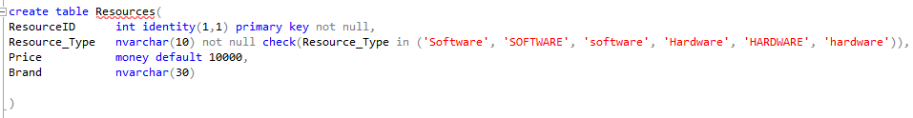

**Pro_Res**

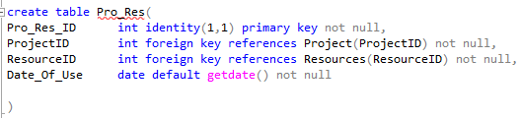

**IT_Department**

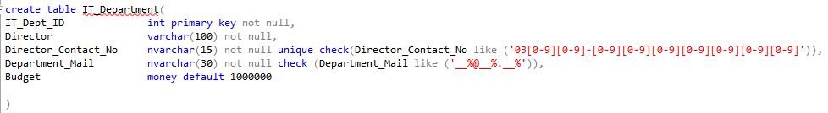

**Pro_Dept**

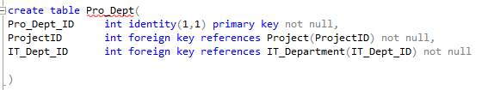

**Client**

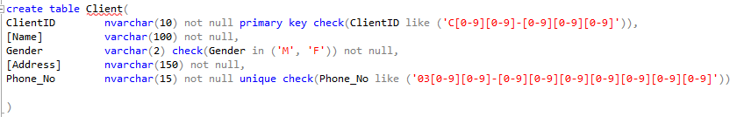

**Contract**

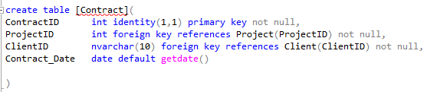

## SQL (DML)

**Employee**

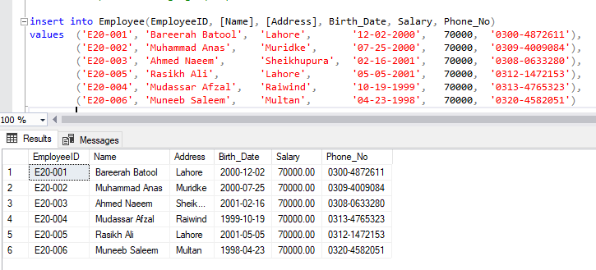

**Project**

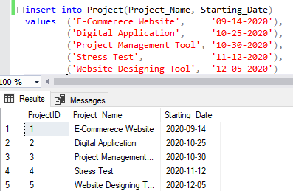

**Resources**

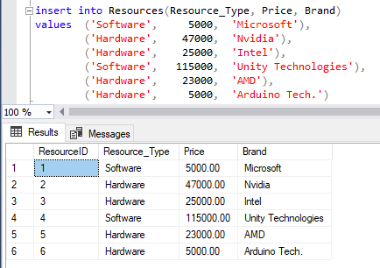

**Client**

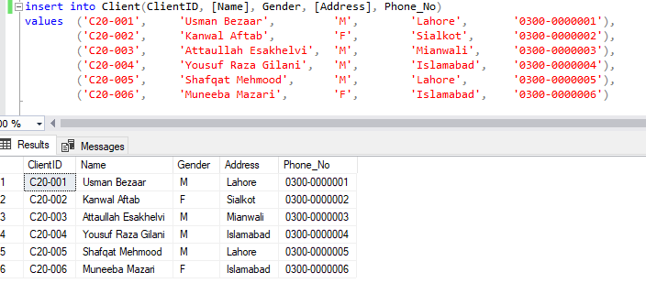

**Project Manager**

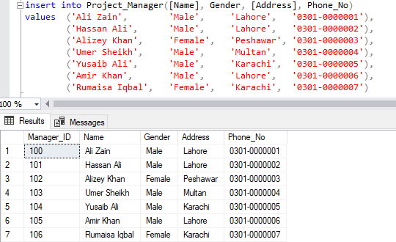

**IT Department**

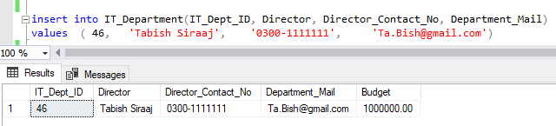

**Contract**

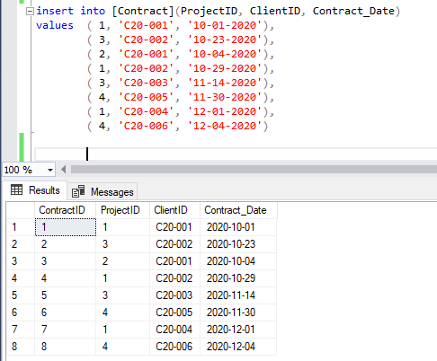

**Pro_Emp**

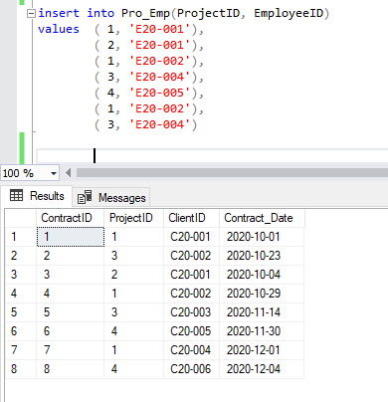

**Pro_Res**

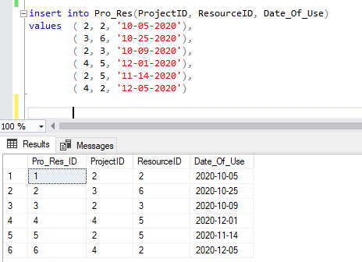

**Pro_Dept**

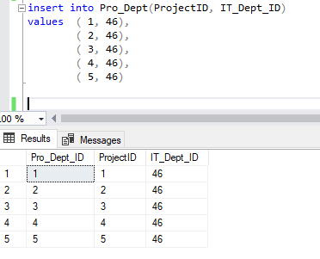

**Pro_Man**

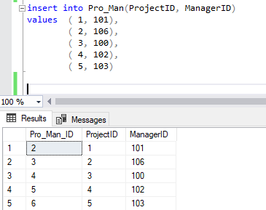

## SQL Query

1. 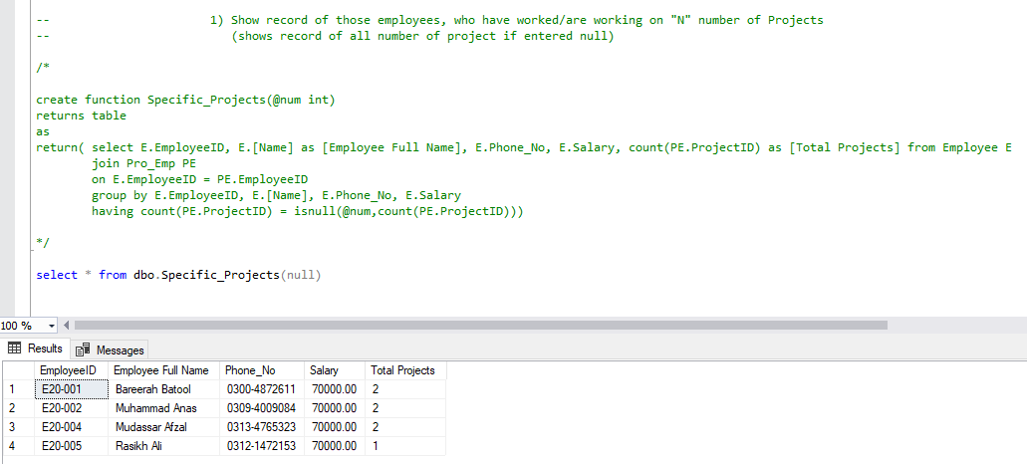
2. 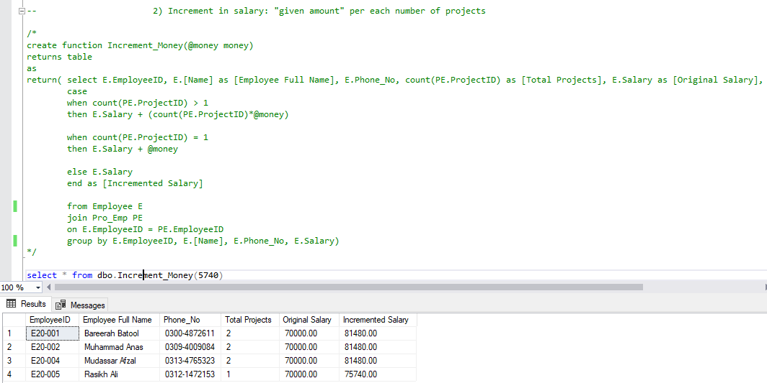
3. 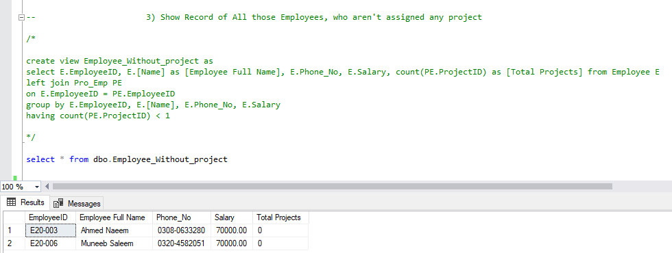
4. 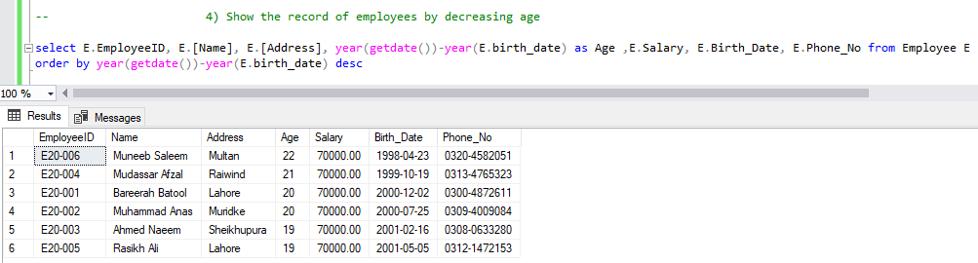
5. 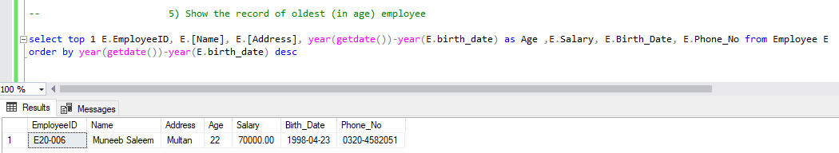
6. 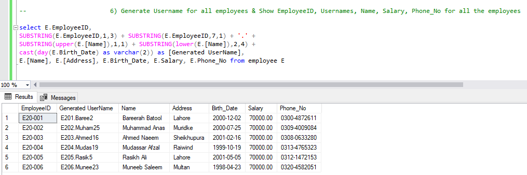
7. 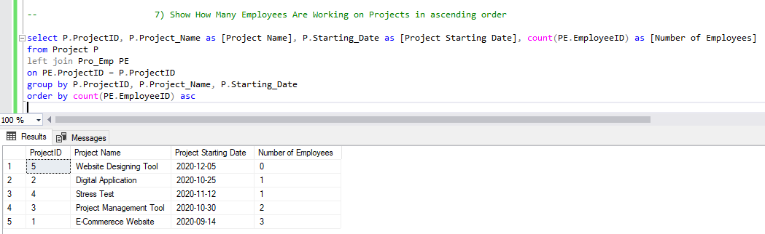
8. 